Iquomi

Intelligent Querying On Managed Infrastructure

Platform OVERVIEW

Date: Friday, August 01, 2003
Author: Peter Theill, Commanigy
Table of Contents

Table of Contents 2
1 Introduction 3
1.1 Document history 3
1.2 Terms 3
2 Components 3
2.1 Data distribution component 4
2.2 Licensing component 4
2.2.1 Producers 4
2.2.2 Consumers 5
2.2.3 Licensing models 6
2.3 Authentication, authorization & encryption component 6
2.3.1 Authentication 7
2.3.2 Authorization 7
2.3.3 Encryption 8
2.4 Notification component 8
3 Modules 8
3.1 Scripting 8
3.2 Object Library 8
3.3 Web service for DDC 8
3.4 Reporting 8
3.5 Maintenance via web site 9
3.5.1 Listing available services 10
4 API Examples 10
4.1 Notification component 10
4.2 Object library 10
4.2.1 Access through VBA 10
4.2.2 Access from ASP.NET application 11
4.3 Charges 11
4.3.1 Service charge 11
4.3.2 Item charge 12
5 References 12
5.1.1 Plan-X Project 12
5.1.2 .NET Alerts 12
5.1.3 Extensible Markup Language (XML) 1.0 (Second Edition) 12
5.1.4 XML Schema 12
5.1.5 XML Path Language (XPath) 12
5.1.6 XQuery 1.0: An XML Query Language 12
5.1.7 Document Object Model (DOM) Level 1 Specification 12
5.1.8 XML-DBMS 13
5.1.9 The XML Databinding Specification 13
5.1.10 Serence KlipFolio – having a really nice user interface 13
5.1.11 HTTP Authentication: Basic and Digest Access Authentication 13
5.1.12 Visual Basic for Applications (VBA) 13
5.1.13 Accessing COM/COM+ Objects Within the ASP.NET Environment 13

Introduction
This document discusses the Iquomi platform by looking at each of the critical components. It’s not describing the components in implementation details but instead gives a high-level overview of the platform and how the components interact.

Document history
Date | Author | Comment
August 5, 2003 | Peter Theill | Initial version.
August 9, 2003 | Peter Theill | Added notification component.
September 4, 2003 | Peter Theill | Added modules descriptions.
September 6, 2003 | Peter Theill | Added Object library and more API examples. Separated “Services” chapter into new document.
September 9, 2003 | Peter Theill | Added more API examples and screenshots.

Terms
Term | Description
AAE | Authentication, Authorization & Encryption
AAEC | AAE Component
Consumer | An end-user using a product made available by the producer.
DDC | Data Distribution Component
LC | Licensing Component
NC | Notification Component
Producer | A 3rd party developer building applications or plug-ins taking advantage of the Iquomi platform.
Store | Data store where any item may be stored without the system knowing what it is; usually done by serializing to an XML format.
WS | Web Service

Components
The Iquomi platform consists of the components as shown in Figure 1. These components are split up so further development does not necessarily need to depend on all components being analyzed, designed and implemented at the same time. Some of the components can be implemented in simple versions and improved later on.


Client
AAE
Component
Licensing Component
Data distribution Component
Notify
Component
Scripting
WS
Reporting
Object Library
Figure 1 The system components

Data distribution component
The platform stores data in a distributed manner. When a service requests to store a piece of data the data distribution component is asked to place it and it’s then up to this component to connect to the data store repository which may be located on a different physical machine and store it securely. Services are allowed to request the DDC to distribute data on only a subset of machines e.g. only on machines hooked up in the LAN.

The retrieval of information from the data store must be fast and efficient, to support the extremely high number of users expected. The data store must be scaleable, so it can be expanded (transparently) as demand grows.

Data can be split into chunks and stored in a defined number of server groups to improve availability and load balancing. It’s a goal for the DDC to ensure a requested resource is located from its source (or sources) and returned as one single resource. The DDC must take ping times (geographic location) from client into account so a resource is located from the fastest origin available. Furthermore the DDC is responsible for keeping the stored data and its mirrors up to date at all times.

Licensing component
The platform defines licensing on two different levels:

- Producers
- Consumers

These levels must be tightly coupled to ensure a generic way for controlling the licensing setup. The two levels are linked by the commonly known logic: “No producers without consumers and no consumers without producers”.

Producers
Products built based on a high-level framework such as the Iquomi platform gains some great advantages over ordinary developed products. Some of these are already discussed in previous sections. An additional benefit for producers is the ability to setup licensing models for the use of their product. The platform defines no boundary for the use of these models so it’s up to the producer to decide how their users (i.e. the “consumers”) should be charged for their service. The platform however defines some basic models c.f. 2.2.3 which could be used in a variety of ways to setup the most applicable licensing model for a given product.

Consumers
Consumers these days are used to have a welt of different ways to pay for a given product. When a consumer goes to buy a new mobile phone it’s possible to get it cheaper if it comes with a predefined subscription. If a consumer goes to the bank and puts all his money, insurances and investments into the same bank it’s cheaper for him in the long run and if a consumer wants to buy an online connection for his computer network at home it’s possible to do so differently based on the total amount of megabytes transferred per month, the total time used online or even a mix of these.

In the software industry this is not fully adapted yet but it’s getting there especially with the increase in broadband connections. Currently consumers go buy a product and pays for the entire product though they may not use all of it. Large corporations (known as ASPs or Application Service Providers) already take this into account an offer consumers to pay a fee whenever they use a product. However this way of doing it is only applicable for large product packages (such as MS Office, Corel Suite and Adobe Frame maker) since the setup is rather tedious and most ASPs won’t even care taking in smaller products such as what’s being developed by part-time shareware developers.

However as mentioned it’s getting there. Most companies selling products online will allow consumers to get a discount if they buy additional products or services. As an example take a consumer who goes buy an anti-virus product. Usually this includes a “free” one-year subscription with virus definition updates. So after a year this product is more or less of no use without extending the subscription which of course is what the producer wants in the first place. There’s a model in this example. The anti-virus corporation could decide to setup this subscription in a dozen of ways such as: two years, three years, per issued definition request, per received definition update, per KB transferred of definition, etc. Of course these could be mingled in at least as many ways to give consumers models which will be acceptable for them while still giving the anti-virus corporation its fair share of revenue.

So, consumers want to have options and producers want to give them these to ensure a consumer will eventually use their product. A producer will of course rather have consumers use their product a little bit than not at all.

Licensing models
Differentiated licensing models can be setup for each user and must be able to apply for each separate service (notes, contacts, files, etc). A service must provide one or more of the models described below.

- Flat-fee model
Users pay a subscription fee. Using this model there is no limit on the number of requests or transferred megabytes a user is allowed to perform. A model like this is used for “Notes” or “Contacts” like services where it’s necessary to make many small requests to get the needed information.
- Pay-per-item model
Users pay for actual requests executed. It’s a known model for “-search” and “news” services, e.g. when performing a query on a highly informative service such as a software archive doing extensive software reviews for their paying customers. By implementing a service wrapping this functionality it would be possible to directly charge per item.
- Pay-per-transfer model
Users pay for amount of megabytes transferred. Some services execute many small queries on a service where the returned response is very large, e.g. a “File” service. It wouldn’t make sense to pay a flat-fee if the user want to store his entire hard drive online nor does it make sense to pay per item since a small file would cost the same as a large file.
- Pay-per-time model
Users accessing a service where limited transfer will or might occur and where limited requests will or might occur needs this model to allow billing for the time used per each request.

Depending on the selected model the service user-interface could change so the licensing model must be available for services.
Having these licensing models will attract customers already providing great services through standard web sites. Consider sites such as “The TV Guide” or “Job Index”. Allowing these established sites to make a service and charge the end-users directly through an Iquomi service would be something they would like to do.

Authentication, authorization & encryption component
Authentication refers to the process of verifying the identity of a user. Authorization refers to the process of establishing and enforcing a user’s rights and privileges to access specified resources. Encryption refers to the process of converting computer data and messages to something incomprehensible by means of a key, so that it can be reconverted only by an authorized recipient holding the matching key.
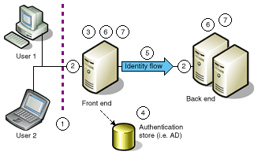Figure 2 depicts a multiple physical tier deployment; however, many smaller applications are implemented on one physical tier, simplifying authentication, authorization, and identity flow. Figure 2 illustrates the following measures to mitigate security threats:
Figure 2 Model of a secure multi-tiered application
- Bandwidth throttling reduces denial of service (DoS) attacks. This prevents applications from becoming swamped by continuous and undesired requests from malicious applications or users.
- Encryption enables secure communication.
- Authentication prevents identity spoofing.
- Authentication verifies credentials against a data store.
- Identity flows between the application tiers (optional).
- Auditing enables reputability.
- Authorization prevents data tampering and exposure threats.

Authentication
In the first part of the security equation, you want users to identify themselves and provide verification that they are who they say they are. The most common way to do this is by requiring a username and password.

Authorization
Once you authenticate that users are who they say they are, you want to provide them with access permission to the company resources necessary to perform their jobs. You also want to restrict them from accessing data that they have no need to use. This process of authorization is usually implemented in the form of user permissions in operating systems, devices, and applications.

As with usernames and passwords, it is best to have user permissions standardized (and centralized, if possible) across various technology platforms. In general, authorization and the technologies used to implement it are tightly bound to authentication, since a user must be identified before being authorized to have access to certain resources. Authorization is defined down to a specific service but is based on an affirmative consent model i.e. nothing is shared unless the subscription owner consents to share that data. The consent model must be simple to define to avoid users making mistakes and thus sharing an incorrect amount of data.

Encryption
Although authentication and authorization are usually tightly integrated, encryption functions in its own sphere. It serves to complement authentication/authorization by protecting data between authorized entities, and it can work independently to protect resources in case authentication/authorization fails to protect those resources from unauthorized users.

Notification component
Any stored item may have a listener attached to it. This allows the framework to notify users of a given service about changes such as “item x updated”. An item has listeners for create, read, update and/or delete events and these listeners are setup either at creation time or added later. See 4.1 for API example.

Modules
Modules are plug-ins to the system extending the functionality on either the server-, client- or both sides.

Scripting
A scripting engine for use on the client allows users to extend a service in a variety of ways the initial service author might not have thought of in the first place.

Object Library
Supporting an object library allow other applications to communicate with Iquomi in a standardized manner using e.g. VBA. VBA is commonly used from the MS Office package.

Web service for DDC
Any client can work directly with the Data Distribution Component through a Web Service. Since web services are an embraced standard, APIs exists for almost any programming language. The Iquomi client doesn’t necessarily need to communicate through this web service though.

Reporting
All activity in the components is logged and can be retrieved through the reporting module. Reports can be generated directly by users accessing the main web site. An example of a generated report is shown in Figure 3.
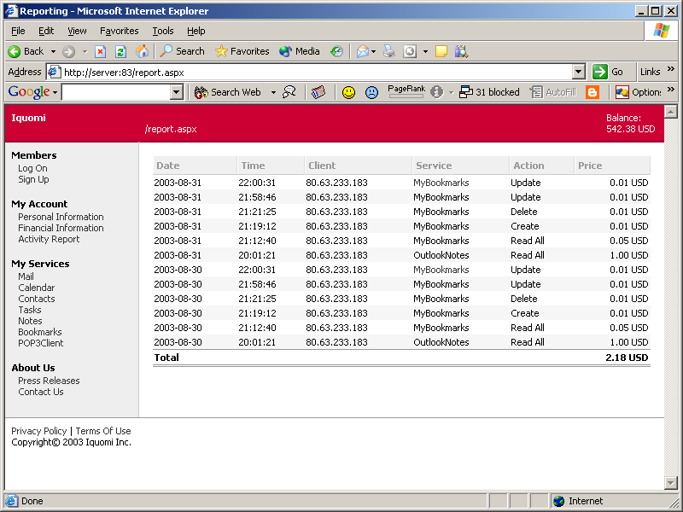
Figure 3 Example of a user-generated report

Maintenance via web site
Ability to list, subscribe and unsubscribe services from a web site allows users to quickly update their client application with the appropriate services.

Listing available services
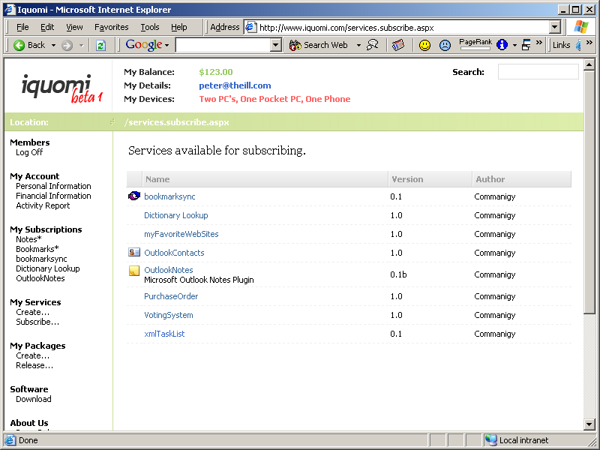
Figure 4 Listing available services

API Examples
This section gives some examples of API use.

Notification component
Setting up new notifications is fast and easy. This functionality will be appreciated by people wanting to use Iquomi to get notified of appointments, a television program, etc.

Item I = new Item();
i.addNotification(NotifyType.UPDATE);
Figure 5 Setting up an update notification for a given item

Object library
An object library is a collection of type/classes wrapping the Iquomi platform functionality to provide ease access for 3rd party applications.

Access through VBA
From Outlook, it might be necessary to communicate a sent email to the Iquomi platform if the user wants to store all email messages.

Private Sub Application_ItemSend(ByVal Item As Object, Cancel As Boolean)
Dim prompt: prompt = "Would you like this to be sent to Iquomi?"
If MsgBox(prompt, vbYesNo) = vbYes Then
' instantiate
Dim iquomi As Iquomi.Application = New Iquomi.Application()

' get Email service
Dim service As Iquomi.Service = iquomi.LocateService("MyEmailService")
service.Authenticate("YourValidProfile", "secret")
' create new item and put Outlooks “Item” into this
Dim item As Iquomi.Item = New Iquomi.Item()
Item.StoreObject = Item
' send item
service.create(item)
End If
End Sub
Figure 6 Using object library from Outlook

Access from ASP.NET application
The ability to use Iquomi from an ASP.NET application allow authors to integrate a service directly into a page e.g. when an end-user subscribes to a newsletter provided by the site author.

<%@ Page Language="C#" %>
<%@ Import Namespace="Iquomi" %>
<!DOCTYPE HTML PUBLIC "-//W3C//DTD HTML 4.0 Transitional//EN"
"http://www.w3.org/TR/REC-html40/loose.dtd">
<html>
<head>
<title>Iquomi from web site</title>
<script language="C#" runat="server">

Service service = Iquomi.ServiceLocator("Newsletter");
Item subscriber = new Item();
subscriber.StoreId = "A509B1A8-37EF-4b3f-8CFC-4F3A74704073";
subscriber.StoreObject = Request.QueryString["email"];
service.create(subscriber);

email.InnerHtml = (string)subscriber.StoreObject;

</script>
</head>

<body>
Hi <div id="email" runat="server" />,

<p>
Thanks for subscribing to our newsletter.
</p>

</body>
</html>
Figure 7 Creating newsletter subscription from ASP.NET

Charges
A service can be charged in a number of ways both on a global or local scope.

Service charge
Services needing to charge for every update to their service can setup a global update model. When update requests go into the service the account is charged.

LicensingModel model = service.getLicensingModel();
Charge charge = new Charge();
charge.Type = ChargeType.UPDATE;
charge.Price = 0.15;
charge.Unit = ChargeUnit.EUR;
model.addCharge(charge);
Figure 8 Adding update charge for entire service

Item charge
For more control over the update mechanism it’s possible to setup charges on specific items. This enables service authors to charge differently depending on the item e.g. a service for updating news item on a site might charge more for a “hot” news update shown on the front page than a standard news update.

Item a = new Item();
a.StoreId = "A509B1A8-37EF-4b3f-8CFC-4F3A74704073";
a = (Item)service.read(a);

Charge charge = new Charge();
charge.Type = ChargeType.UPDATE;
charge.Price = 0.05;
charge.Unit = ChargeUnit.EUR;

LicensingModel model = a.getLicensingModel();
model.addCharge(charge);
Figure 9 Adding update charge for a specific item

References

Plan-X Project
http://www.plan-x.org/

.NET Alerts
http://alerts.microsoft.com/

Extensible Markup Language (XML) 1.0 (Second Edition)
http://www.w3.org/TR/REC-xml

XML Schema
http://www.w3c.org/TR/xmlschema-0/
http://www.w3c.org/TR/xmlschema-1/
http://www.w3c.org/TR/xmlschema-2/

XML Path Language (XPath)
http://www.w3c.org/TR/xpath

XQuery 1.0: An XML Query Language
http://www.w3.org/TR/xquery/

Document Object Model (DOM) Level 1 Specification
http://www.w3.org/TR/REC-DOM-Level-1/

XML-DBMS
http://www.rpbourret.com/xmldbms/

The XML Databinding Specification
http://www.oasis-open.org/cover/xmlDataBinding.html

Serence KlipFolio – having a really nice user interface
http://www.serence.com/site.php?page=prod_klipfolio

HTTP Authentication: Basic and Digest Access Authentication
http://rfc.sunsite.dk/rfc/rfc2617.html

Visual Basic for Applications (VBA)
http://msdn.microsoft.com/vba/
http://msdn.microsoft.com/vba/prodinfo/backgrounder.asp#whatis

Accessing COM/COM+ Objects Within the ASP.NET Environment
http://windows.oreilly.com/news/developasp_0301.html

